
User Guide
(UG)

MailSpeak Application (MSA)
University of Maryland Global Campus (UMGC)
Software Engineering (SWEN) 670
Fall Cohort 2022
Team B
November 5, 2022
Approval Signatures

☐ APPROVE  ☐ DISAPPROVE | Tatiana Kozhevnikova, Product Owner  Date: _____________
☐ APPROVE  ☐ DISAPPROVE | Michael Conatser, Project Manager  Date: _____________

Document Control

Document Information
 | Information
Document Id | USPS- MSA-UG-20221004-Fall2022
Document Owner | UMGC SWEN 670
Issue Date | November 5, 2022
Last Saved Date | November 5, 2022
File Name | UG – Team B MSA.docx

Document History
Version | Issue Date | Changes
0.1 | 10/9/2022 | Initial draft
0.2 | 11/4/2022 | Review updates
2.0 | 11/5/2022 | Final deliverable

Table of Contents
1 Introduction 5
1.1 Background 5
1.2 Project Documentation 5
1.2.1 Project Suite of Documents 5
1.2.2 Document References 5
2 System Capabilities 6
2.1 Overview 6
2.2 General Description 6
3 Specifications 6
3.1 Software Specifications 6
3.2 Hardware Specifications 6
3.3 Technical Specifications 6
4 Description of System Functions 7
4.1 Login 7
4.2 Main Menu 8
4.3 Settings 9
4.4 Search 10
4.5 Chatbot 11
4.6 Accessibility 12
4.6.1 Android Accessibility Tools 12
4.6.2 iOS Accessibility Tools 16
5 Troubleshooting 19
5.1 App Crashes 19
5.2 Unable to Scan or Upload Mail 19
5.3 Unable to login to email account 20
Attachment A — Acronyms and Abbreviations 21
Attachment B — Accessibility Elements Label Names 22

Introduction

Background
MailSpeak (MSA) is a mobile application that works in tandem with a user’s USPS Informed Delivery account and emails received through the USPS Informed Delivery program. With special attention given to vision-impaired users, this application provides users with the ability to navigate through the mail pieces emailed to the user by Informed Delivery. Development began with the previous UMGC SWEN 670 Capstone Summer 2022 cohort and is currently being developed by the Fall 2022 cohort. The application allows users to search through mail pieces Informed Delivery has informed them they will receive by both keyword and date. For visually impaired users, native voice-to-text and text-to-speech functions are compatible. Additionally, gesture commands are available for increased ease of use. The application also has a Chat Bot feature to assist the user with navigating the application.

Project Documentation

Project Suite of Documents
This User Guide (UG) is part of a set of essential documents created to adequately manage, control and deliver the Mail Speak Application. Artifacts that are provided within the document package contain vital information for the application’s ongoing support and operation throughout its life cycle. Each document is created within the specific Milestone of the project.
Table 1.2.1 - Project Documentation Package
Document | Version | Date
Project Management Plan (PMP) | 4.0 | 11/05/2022
Software Requirements Specification | 4.0 | 11/05/2022
Technical Design Document | 3.0 | 11/05/2022
Software Test Plan | 3.0 | 11/05/2022
Programmer Guide | 2.0 | 11/05/2022
Development and Operations Guide | 2.0 | 11/05/2022
User Guide | 1.0 | 11/05/2022
Test Report | 1.0 | 11/05/2022

Document References
During the process of writing current UG the following documents were referenced:
- Team B. (2022). United Global Master Coders Team B PMP. https://umgcdev361.sharepoint.com/:w:/r/sites/SWEN670Fall2022/Shared%20Documents/Team%20B%20Channel/Milestone%201%20(SAT%20SEP%203)/ProjectManager-Project-Plan-Template.docx?d=w671384dfe89d46d7a2583b60416fb909&csf=1&web=1&e=xeRN2o
- Team B. (2022). United Global Master Coders Team B SRS. https://umgcdev361.sharepoint.com/:w:/r/sites/SWEN670Fall2022/Shared%20Documents/Team%20B%20Channel/Milestone%201%20(SAT%20SEP%203)/Informed%20Delivery%20Enhancement%20Team%20B%20SRS.docx?d=w9b27ad03c5c145a09edc6b22427bc8ba&csf=1&web=1&e=85qCsH
- Team B. (2022). United Global Master Coders Team B TDD. https://umgcdev361.sharepoint.com/:w:/r/sites/SWEN670Fall2022/Shared%20Documents/Team%20B%20Channel/Milestone%202%20(SAT%20SEP%2017)/TDD%20-%20Team%20B%20-%20MSA.docx?d=wf0a49ae72fc0497b9dfb0322352b8025&csf=1&web=1&e=fgAyQh

System Capabilities

Overview
The purpose of the MSA is to provide users with easy access to the mail information they received through USPS Informed Delivery.

General Description
The main goals of this application are to provide accessibility features to visually impaired users. Users can use their native text-to-speech setting within the application, and voice- and gesture-driven commands have been implemented. The search feature can be used to search for specific pieces of mail, using a keyword and/or a date range. Additionally, a Chatbot is available to assist users in navigating the application.

Specifications

Software Specifications
Recommended:
- Android: Android 12 (Snow Cone)
- iOS: iOS 16

Hardware Specifications
MSA can be used on any mobile device or tablet that is able to download applications from either the Google Play Store or Apple App Store. It is not compatible with computers.

Technical Specifications
The minimum requirements for using the application are:
- Android: Android 5.0 (Lollipop) with API Level 21
- iOS: iOS 13

Description of System Functions

Login
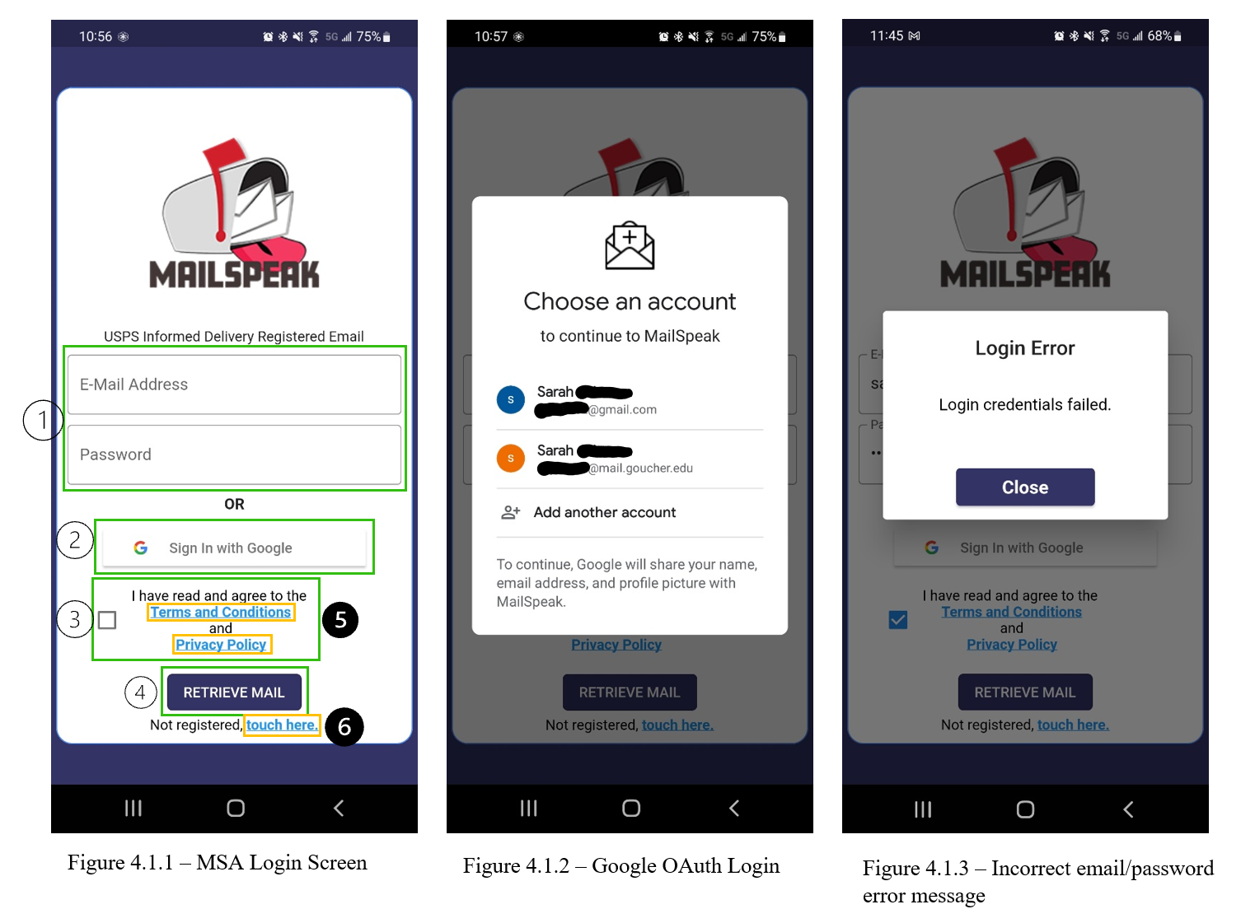
To access the application and their scanned mail, users must login:
- Enter the email address the user has registered with USPS Informed Delivery and enter the email password (Figure 4.1.1 Area 1).
- Confirm that they have read the terms and conditions (Figure 4.1.1 Area 3).
- Click “Retrieve Mail” (Figure 4.1.1 Area 4).
- The user will be logged into the app and will be brought to the main menu.
If the user has registered with a Gmail email account:
- Confirm that they have read the term and conditions.
- Click the Google OAuth button (Figure 4.1.1 Area 2).
- Select the Gmail account (Figure 4.1.2).
If users have not registered for USPS Informed Delivery:
- A link is provided to take them to the registration web page (Figure 5.1.1 Area 6).
There are also links to the Private Policy and Term and Conditions (Figure 4.1.1 Area 5).
If the user enters an incorrect email or password:
- An error message will be displayed, informing them of incorrect login credentials (Figure 4.1.3).

Main Menu
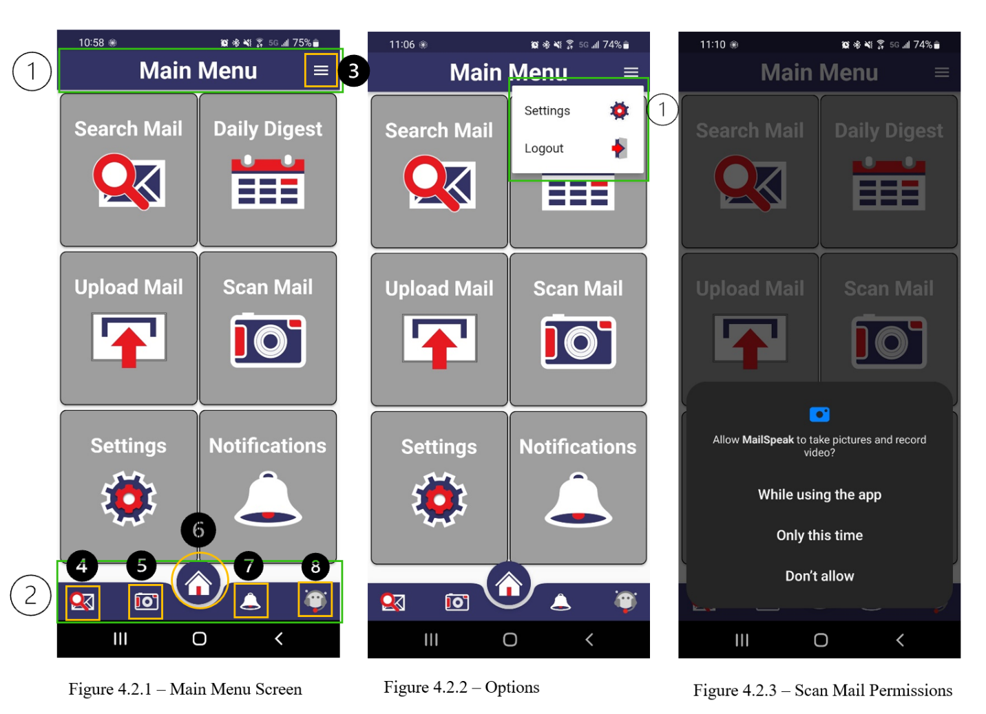
The main menu is set up in a grid (Figure 4.2.1).
Top Toolbar (Figure 4.3.1 Area 1):
- There is a hamburger button (Figure 4.2.1 Area 3) at the far right.
- When expanded, the hamburger button has two selections: settings and log out (Figure 4.2.2).
- Clicking settings will take the user to the settings screen.
- Clicking logout will log the user out of the application and take the user back to the login screen.
The grid of the main menu is set up in a 3 rows x 2 columns grid.
- From top to bottom, left to right, there are: “Search Mail”, “Daily Digest”, “Upload Mail”, “Scan Mail”, “Settings”, and “Notifications”.
- Clicking “Search Mail”, “Daily Digest”, “Settings”, or “Notifications” will take the user to the respective screens.
- Clicking “Upload Mail” will take the user to their phone’s gallery where they can select a photo to upload.
- Selecting “Scan Mail”, the user will first have to give MSA permission to use the phone’s camera and gallery (Figure 4.2.3). Granting the application permission will then open the phone’s camera and the user can take a photo of the mail piece to upload.
Bottom Toolbar (Figure 4.2.1 Area 2):
- This toolbar is displayed on every screen, allowing the user to navigate to the screens from anywhere in the application.
- From left to right are the icons for “Search Mail” (Figure 4.2.1 Area 4), “Scan Mail” (Area 5), “Main Menu” (Area 6), “Notifications” (Area 7), and “Chat bot” (Area 8).
- Selecting any of these icons will take the user to the corresponding screen.

Settings
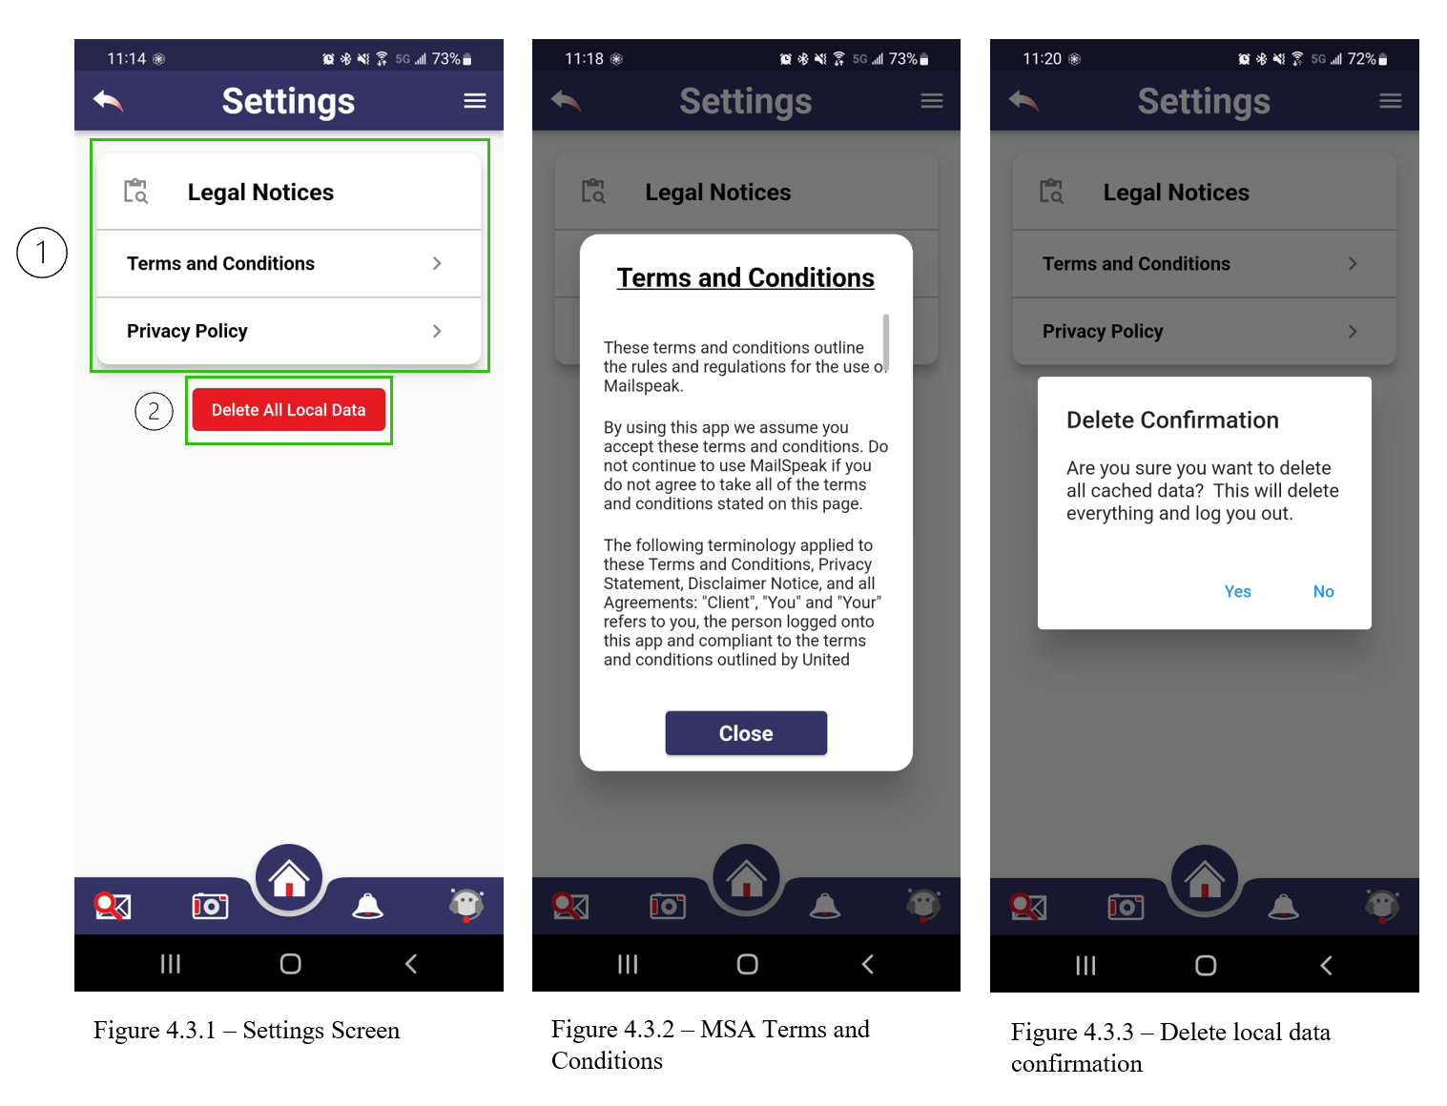
Selecting the “Settings” option from the hamburger icon in the top toolbar from any screen will take the user to the “Settings” screen (Figure 4.3.1).
This screen contains options to:
- View the “Terms and Conditions” and “Privacy Policy” (Figure 4.3.1 Area 1). Selecting either of these options will display the respective text in a dialog box (Figure 4.3.2).
- “Delete All Local Data” (Figure 4.3.1 Area 2): Selecting this button will open a dialog screen where the user is asked to confirm they wish to delete all local data (Figure 4.3.3). Selecting “Yes” will delete all cached data, log the user out of the app, and bring them to the login screen.

Search
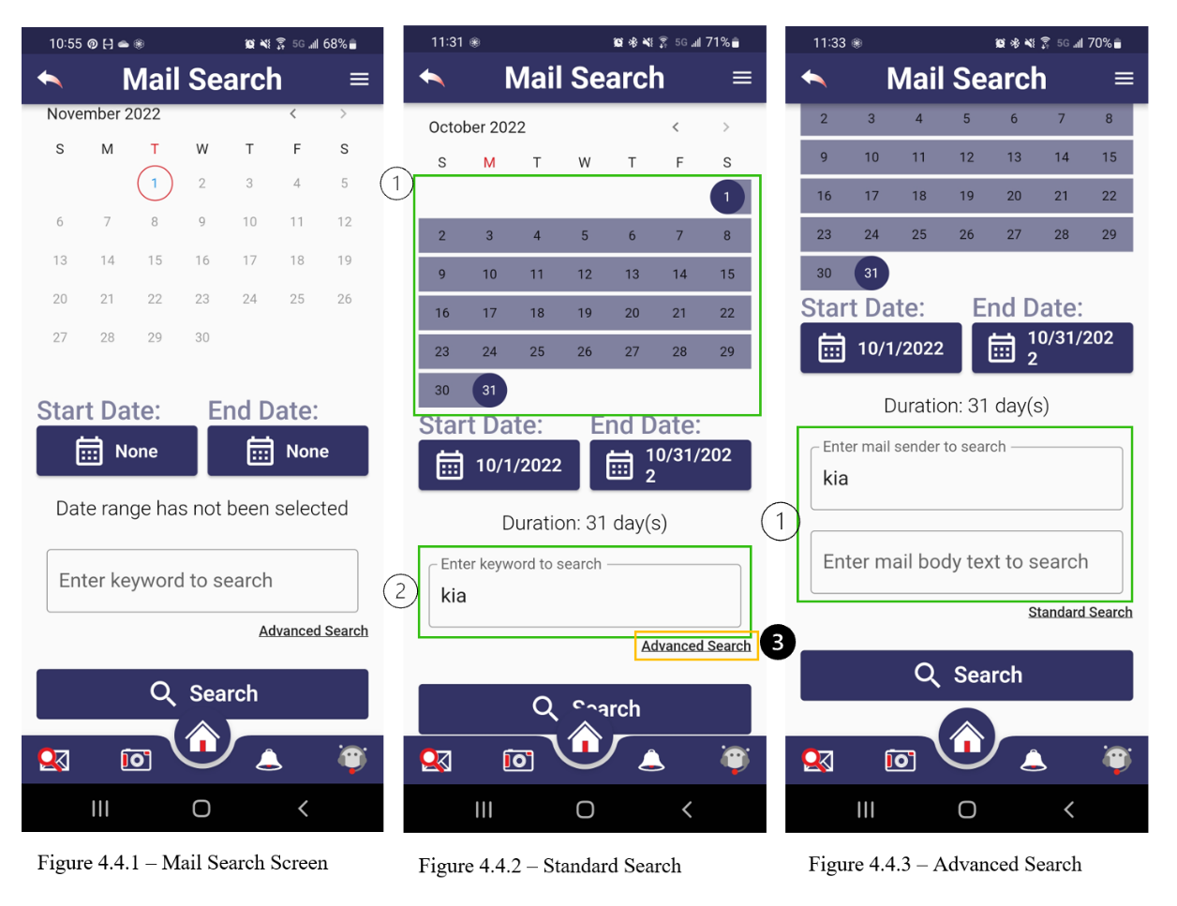
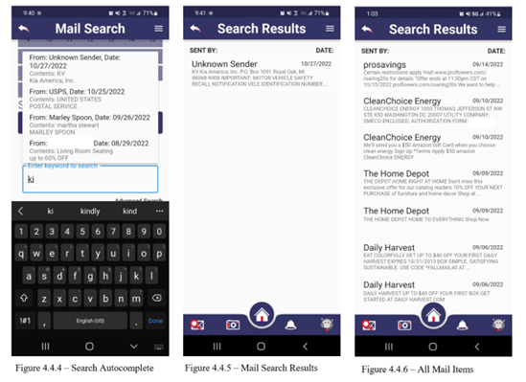
To search for specific mail pieces, the search feature can be used (Figure 4.4.1).
This screen contains:
- A calendar where the user can select a single date or a date range to search between (Figure 4.4.2 Area 1).
- After selecting a start date and end date, the days included in the search are highlighted in the calendar, the start and end dates and the duration of the search are displayed below the calendar.
- Below this, there is a text field where the user can type in a keyword to search by (Figure 4.4.2 Area 2).
- As the user is typing in a keyword, the autocomplete will display suggestions (Figure 4.4.4).
- An “Advanced Search” (Figure 4.4.2 Area 3) allows the user to specify where to search for the keyword. They can search by the mail sender or by the body text (Figure 4.4.3 Area 1).
- Once the user selects the date range and/or keyword and selects the “Search” button, all the mail pieces matching the criteria will be displayed in a list in the “Search Results” screen (Figure 4.4.5).
- The user can also view all the mail pieces in their local storage by leaving the date range unselected, not entering a keyword to search, and selecting the “Search” button (Figure 4.4.6).

Chatbot
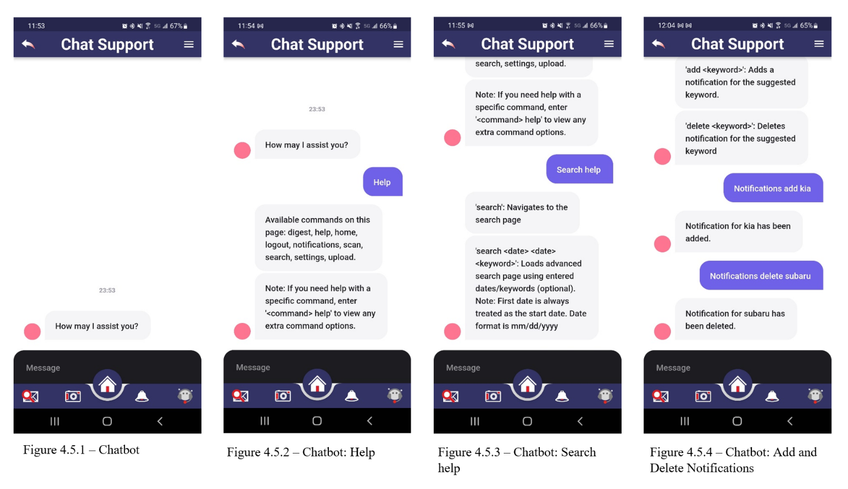
The Chatbot feature assists users in navigating the application (Figure 4.5.1).
Through the Chatbot:
- Users can access the search feature; navigate to the settings page; and view, add, or remove notifications.
- Typing “help” into the chat bot will display the possible commands (Figure 4.5.2). These include: “digest”, “help”, “home”, “logout”, “notifications”, “scan”, “search”, “settings”, and “upload”.
- To find more information about each command, typing in the command and “help” (Figure 4.5.3).
- Simply typing in the basic commands of “digest”, “home”, “notifications”, “search”, and “settings” will take the user to the respective screen.
- Typing in “logout” will log the user out of the application and return them to the login screen.
- Typing in “scan” will open the device’s camera and “upload” will open the gallery application.
- “Notifications” and “search” have child commands to perform more specific actions.
  - Typing in “notifications add [keyword]” will add a notification for the keyword.
  - Typing in “notifications delete [keyword]” will delete the notification for the keyword (Figure 4.5.4).
  - Typing in “search [keyword]” will perform a search for the keyword with the current date selected for the date range.
  - Typing in “search MM/DD/YYYY [keyword]” will perform a search of the keyword with the entered date selected for the date range.
  - Typing in “search MM/DD/YYYY MM/DD/YYYY [keyword]” will perform a search of the keyword with the first date entered being the start date and the second date entered being the end date of the date range.

Accessibility
Accessibility features rely on a device built-in accessibility tool, which allows users with disabilities to interact with the app in a familiar way. The instructions on how to use specific accessibility tools can be found in the accessibility settings of the user’s device. The current User Guide provides basic accessibility gestures and commands that will allow accessing all main features of the MailSpeak app.

Android Accessibility Tools
TalkBack
TalkBack is a screen reader that speaks screen content to a user. To enable Android Screen Reading tools, follow the instructions below:
- Open the Settings app
- Tap ‘Accessibility’ > ‘TalkBack’
- Enable ‘Use TalkBack’
- Go through tutorial until completion
- Note: To disable, double tap the slider for ‘Use TalkBack’
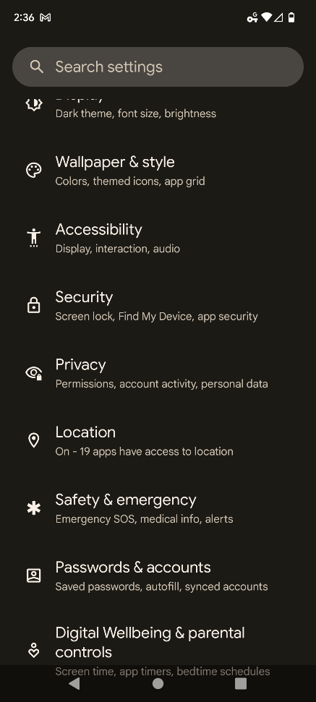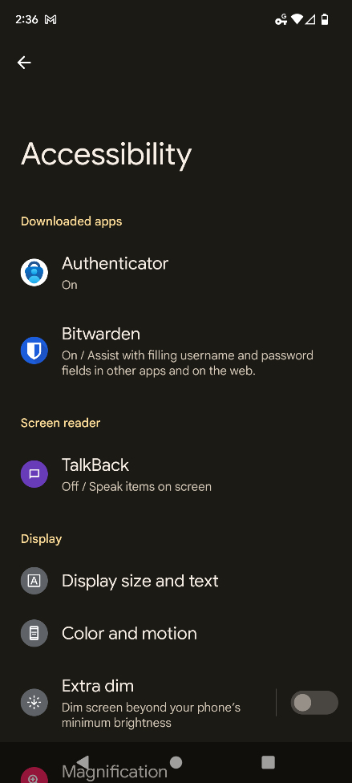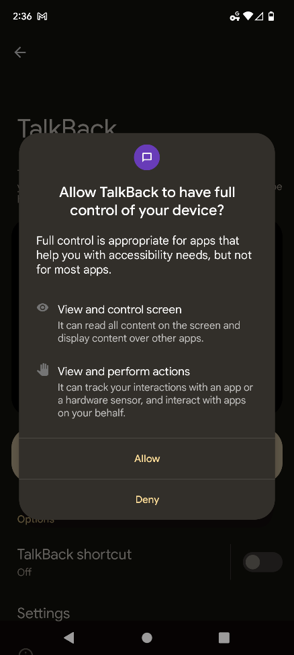
Figure 4.6.1 - How to Enable TalkBack
Common ways to navigate the screen using TalkBack would be:
- Dragging one finger around the screen to hear announcements of icons, buttons and other items.
- Swiping down or up with one finger to hear one item at a time.
When the new screen of the application is opened the TalkBack will automatically highlight and announce the screen heading (Figure 4.6.2). While exploring the screen with TalkBack the selected item will be also highlighted and announced (Figure 4.6.3).
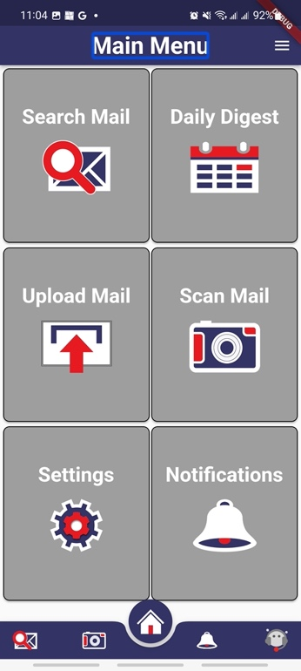 | 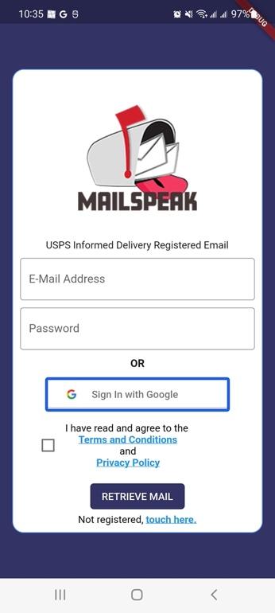
Figure 4.6.2 – TalkBack: Main Menu with Highlighted Screen Heading | Figure 4.6.3 - TalkBack: Login with Highlighted "Sign In with Google" Button
Some basic gestures that can be used:
- Single tap with two fingers – pause or resume reading.
- Triple tap with two fingers – read continuously from this point on.
- Double tap with one finger – activate selected element.
- Swipe down / swipe right with one finger – read next item.
- Swipe up / swipe left with one finger – read previous item.
Voice Access
Voice Access allows controlling device with spoken commands. To activate Voice Access perform the following steps:
- Open the Settings app
- Tap ‘Accessibility’ > ‘Interaction and dexterity’ > ‘Voice Access’ (prompted to install if not on the device)
- Allow ‘Voice Access’
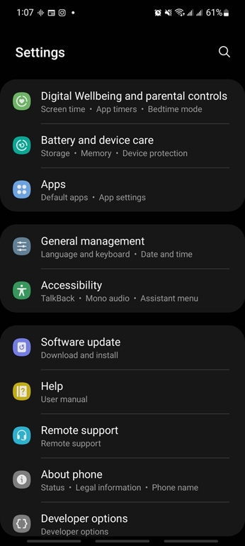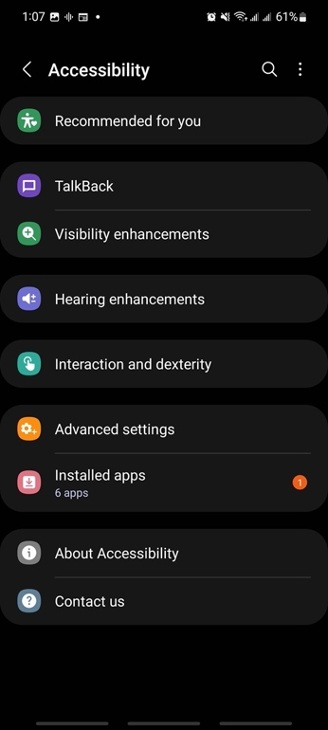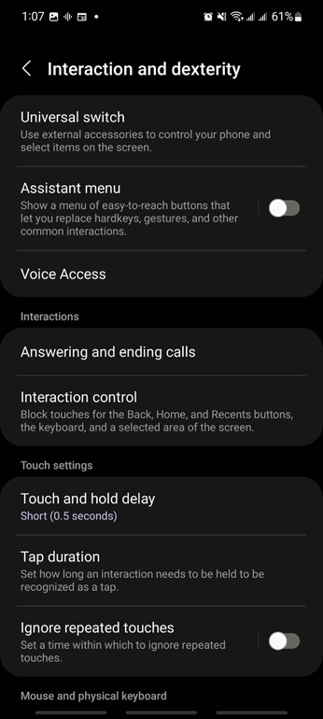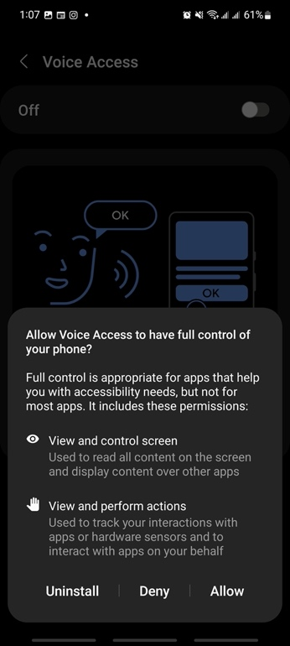
Figure 4.6.4 - How to Enable Voice Access
Elements on the screen can be accessed through the label name or number. Android’s Voice Access on the command “show labels” displays label numbers (Figure 4.6.5 and Figure 4.6.6). The full list of accessibility label names used in the MailSpeak application can be found in Attachment B.
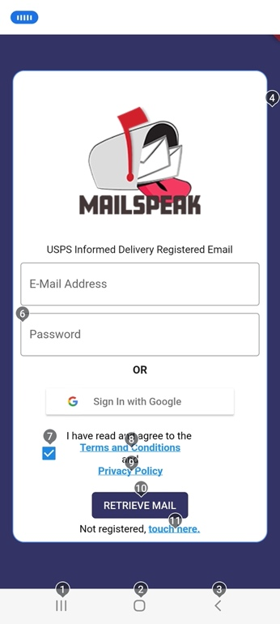 | 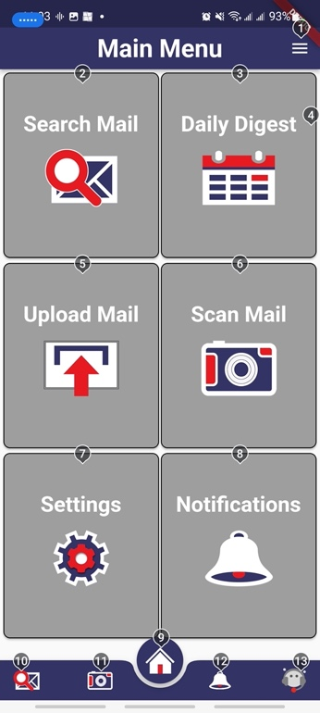
Figure 4.6.5 - Voice Access: Login with Shown Labels | Figure 4.6.6 – Voice Access: Main Menu with Shown Labels
Basic voice commands that can be used in the application:
- “show labels” – displays names of the elements on the screen
- “hide labels” – stops displaying names of the elements on the screen
- “tap <label name/number>” – allows to tap any accessible element on the screen
- “scroll up” – scrolls screen up.
- “scroll down” – scrolls screen down.
- “help” – shows commands available on the screen
- “stop listening” – pauses Voice Access

iOS Accessibility Tools
VoiceOver
VoiceOver is a screen reader that allows users to interact with the app without seeing the screen. To enable iOS Screen Reading tools, follow the instructions below:
- Go to ‘Settings’ > ’Accessibility’ > ‘VoiceOver’
- Turn feature On/Off
- Alternatively, you can activate Siri and say ‘Turn on VoiceOver’
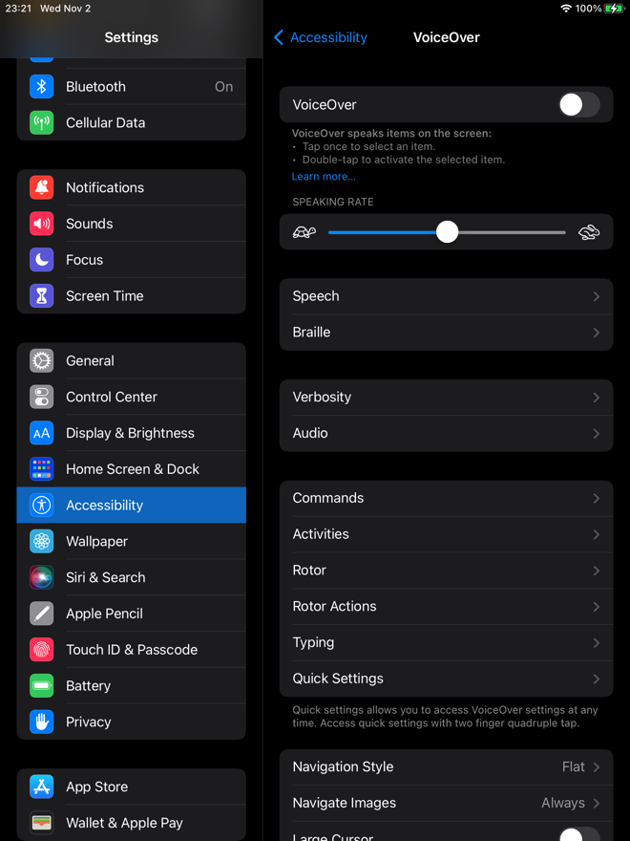
Figure 4.6.7 - How to Enable VoiceOver
To navigate the screen using VoiceOver user can:
- Dragging one finger around the screen to hear announcements of icons, buttons and other items.
- Swiping right or left with one finger to hear one item at a time.
When the new screen of the application is opened the VoiceOver will automatically announce the screen heading and highlight it (Figure 4.6.8). While navigating the screen with VoiceOver each selected item will be highlighted and announced (Figure 4.6.9).
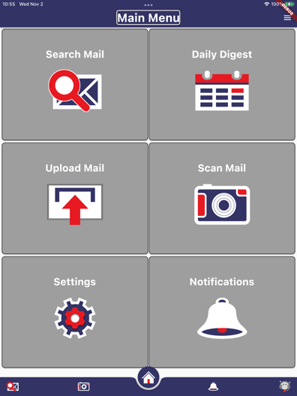 | 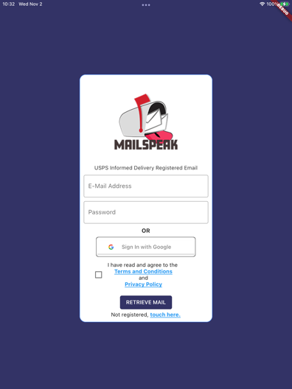
Figure 4.6.8 – VoiceOver: Main Menu with Shown Labels | Figure 4.6.9 – VoiceOver: Login with Shown Labels
Some gestures that can be used:
- Single tap with one fingers – speak item.
- Two finger swipe up – read continuously from top.
- Two finger swipe down – read continuously from this point on.
- Double tap with one finger – activate selected element.
- Swipe right with one finger – read next item.
- Swipe left with one finger – read previous item.
Voice Control
Voice Control allows the user to navigate the app using their voice. To activate Voice Control, perform following steps:
- Go to ‘Settings’ > ’Accessibility’ > ‘Voice Control’
- Turn feature On/Off
- Alternatively, you can activate Siri and say ‘Turn on Voice Control”
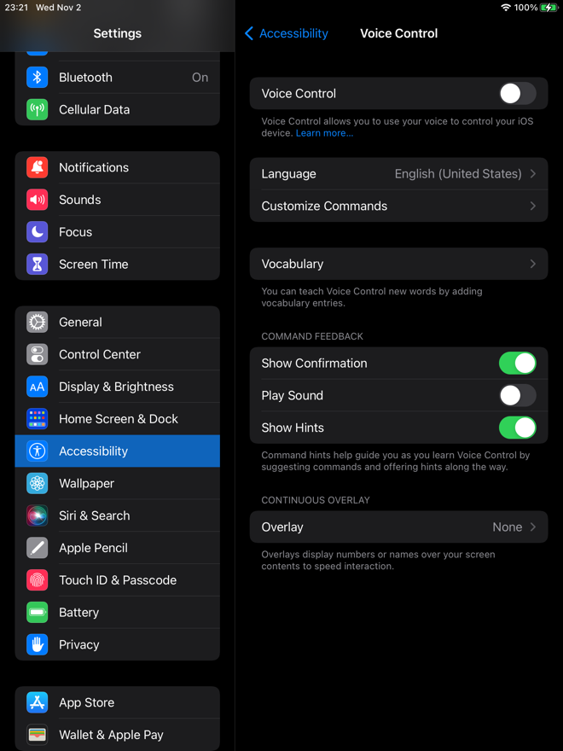
Figure 4.6.10 - How to Enable Voice Control
Voice Control commands “show names” and “show numbers” allow accessing screen elements through their label names (Figure 4.6.11 and 4.6.12) or numbers (Figure 4.6.13). Attachment B contains the full list of elements label names used in the MailSpeak application.
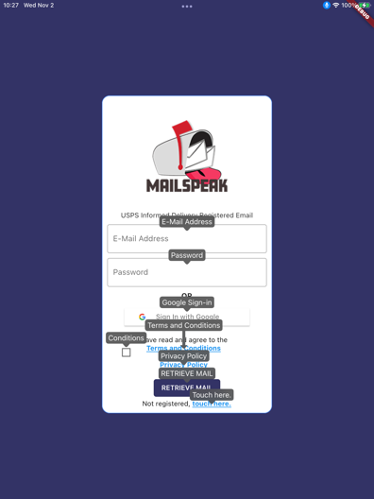 | 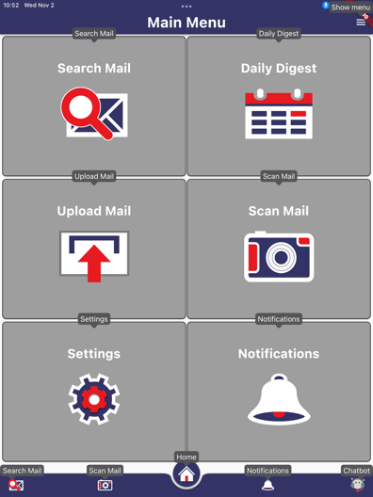 | 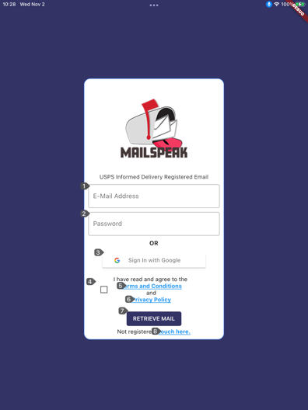
Figure 4.6.11 - Voice Control: Login with Shown Names | Figure 4.6.12 - Voice Control: Login with Shown Names | Figure 4.6.13 - Voice Control: Login with Shown Numbers
Basic Voice Control commands that can be used within the application:
- “show names” – displays names of the elements on the screen.
- “show numbers” – displays numbers of the elements on the screen.
- “hide names” – stops displaying name of the elements on the screen.
- “hide numbers” – stops displaying numbers of the elements on the screen.
- “scroll up” – scrolls screen up.
- “scroll down” – scrolls screen down.
- “tap <label name/number>” – allows to tap any accessible element on the screen.

Troubleshooting
This section is to help with issues that may occur while using the application.

App Crashes
If the application crashes unexpectedly while in use, it is recommended that the user force quit the application. This can be done by navigating to the recent applications view and closing the application. The user can then reopen the application.

Unable to Scan or Upload Mail
If a user is unable to scan or upload mail, it is likely the application does not have the proper permission. To check and set the correct permissions:
- On the device’s home screen, find the MailSpeak application.
- Press and hold on the application until the actions menu of the app opens (Figure 5.2.1).
- Press either “App Info” or the Information Icon (Figure 5.2.1 Area 1).
- Go to permissions (Figure 5.2.2).
- “Camera” and “Files and media” should be under “Allowed” (Figure 5.2.3)
- If they are not: select either one and select either “Allow only while using app” or “Ask every time”, then do the same for the other (Figure 5.2.4).
- Restart the Application.
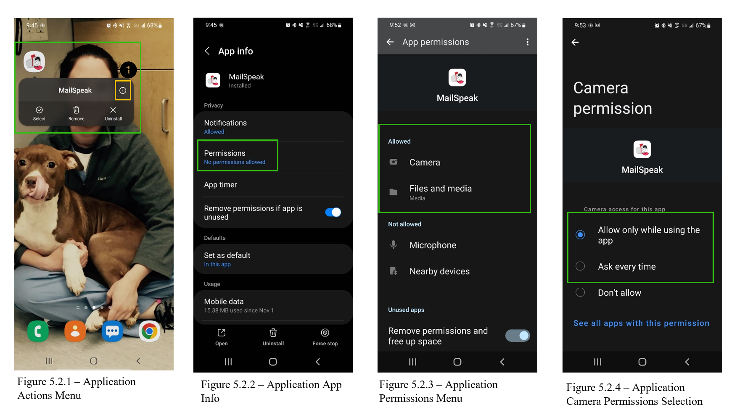

Unable to login to email account
Certain email accounts require use of an app password to login to MailSpeak. If you try to log into the application using valid credentials and receive a login error, this is most likely the issue.

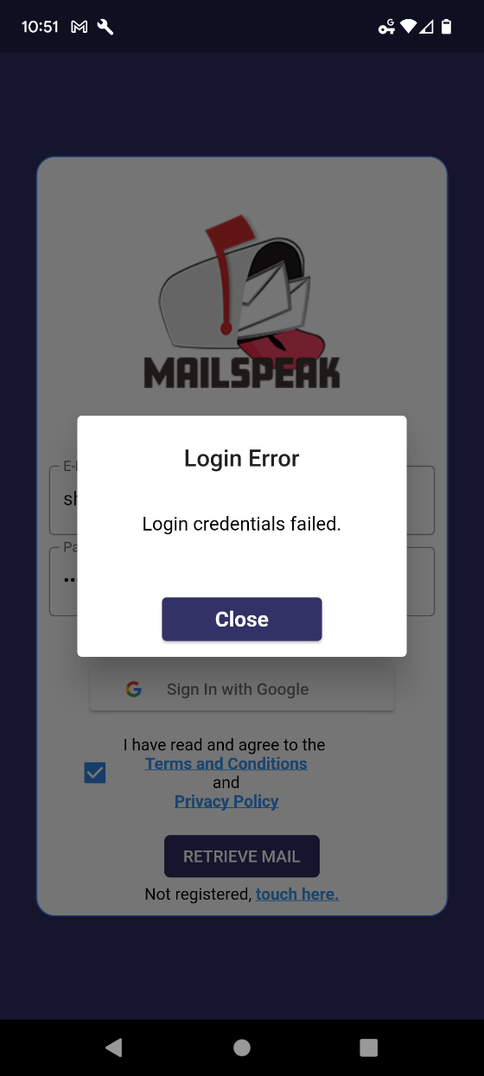

Figure 5.3.1 Login Error with Valid Credentials
To fix this issue, an App Password must be generated for the account. Different mail providers require slightly different processes so do a search on “<your mail provider> app password” and hopefully you can configure it. Below is a list of some common ones.
- AOL: https://help.aol.com/articles/Create-and-manage-app-password
- Yahoo: https://help.yahoo.com/kb/SLN15241.html
- Gmail: https://support.google.com/accounts/answer/185833?hl=en
- Outlook: https://support.microsoft.com/en-us/account-billing/using-app-passwords-with-apps-that-don-t-support-two-step-verification-5896ed9b-4263-e681-128a-a6f2979a7944

Attachment A — Acronyms and Abbreviations
Term | Meaning
iOS | iPhone Operating System
MSA | MailSpeak Application
SWEN | Software Engineering
UG | User Guide
UI | User Interface
UMGC | University of Maryland Global Campus
USPS | United States Postal Service

Attachment B — Accessibility Elements Label Names
Upload Mail and Scan Mail use native to device features, therefore, their User Interface (UI) elements are left out of this guide.
Label Name | UI Control
Top Bar
Back | Back button
Show Menu | “Hamburger” menu button (top bar menu)
Top Bar Menu
Settings | Settings button within dropdown menu
Logout | Logout button within dropdown menu
Bottom Bar
Home | Home button
Search Mail | Search mail button
Scan Mail | Scan mail button
Notifications | Notifications button
Chatbot | Chatbot button
Login Screen
E-Mail Address | E-mail address text field
Password | Password text field
Google Sign-in | Sign in with Google button
Conditions | “Terms and Conditions” and “Privacy policy” checkbox allows user to switch between checked and unchecked
Terms and Conditions | “Terms and Conditions” link opens dialog with “Terms and Conditions” full text.
Privacy Policy | “Privacy Policy” link opens dialog with “Privacy Policy” full text.
RETRIEVE MAIL | Retrieve mail button
Touch here | Touch here link that transfers user to Informed Delivery sign up page.
Main Menu
Search Mail | Search mail button
Daily Digest | Daily digest button
Upload Mail | Upload button
Scan Mail | Scan mail button
Settings | Settings button
Notifications | Notifications button
Mail Search
Backward | Backward button that shows previous month in the calendar view
Forward | Forward button that shows nest month in the calendar view
Start Date | Start date button
End Date | End date button
Keyword | Keyword text field
Sender Keyword | Sender keyword text field
In-Text keyword | In-text keyword text field
Advanced Search | Advances search button
Standard Search | Standard search button
Search | Search button
Search Results
Letter from <sender> received on <EEE MMM dd> | Individual mail piece link
Mail Piece
View <link address> (if any) | View link that was found within the mail piece
Learn More | Learn more button
Set a Reminder | Set reminder button
Daily Digest
Links | Links button
All Details | All details button opens mail piece screen
Backward | Backward button allows navigation to the previous mail piece
Forward | Forward button allows navigation to the next mail piece
Settings
Terms and Conditions | Terms and conditions button that opens dialog pop-up
Privacy Policy | Privacy Policy button that opens dialog pop-up
Delete Local Data | Delete All Local Data button that triggers confirmation pop-up
Dialog Pop-up
Close | Close button
Yes | Yes button in confirmation pup-up
No | No button in confirmation pup-up
Notifications
Manage Tab
Keyword | Keyword text field
Add | Add button
Delete <keyword> | Delete <keyword> button removes specified notification subscription from the list
Notifications Tab
Clear All | Clear All button removes all notifications
Go to <keyword> Message | Go to <keyword> Message button opens mail piece associated with the <keyword>
Clear <keyword> | Clear <keyword> button removes notification associated with the <keyword>
Chat Support
Message (Android) | Message text field
6 (iOS) | Message text field
Send | Send button appears after message is entered into the text field

